Ideation Phase
Define the Problem Statements

Date | 31 January 2025
Team ID | LTVIP2026TMIDS41308
Project Name | online payments fraud detection using machine learning
Maximum Marks | 2 Marks

Customer Problem Statement Template:
Create a problem statement to understand your customer's point of view. The Customer Problem Statement template helps you focus on what matters to create experiences people will love.
A well-articulated customer problem statement allows you and your team to find the ideal solution for the challenges your customers face. Throughout the process, you’ll also be able to empathize with your customers, which helps you better understand how they perceive your product or service.
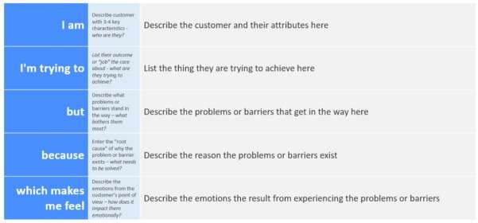
Reference: https://miro.com/templates/customer-problem-statement/
Example:
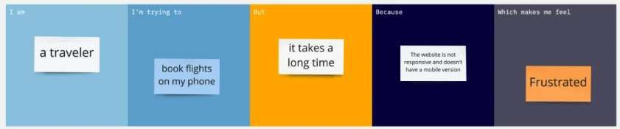

Problem  Statement (PS) | I am  (Customer) | I’m trying to | But | Because | Which makes me feel
PS-1 | I am an online banking customer | I’m trying to make a secure online payment | But my transactio n  sometime  s gets declined or delayed unexpect edly | Because the system flags legitimate transactions as suspicious | Which makes me feel frustrated and worried  about my account  reliability
PS-2 | I am a frequent online shopper | I’m trying to complete payments quickly and safely | But I fear my card or account details may be misused | Because fraudsters  exploit weak detection  systems and real-time  monitoring gaps | Which makes me feel insecure and hesitant to use digital payments

